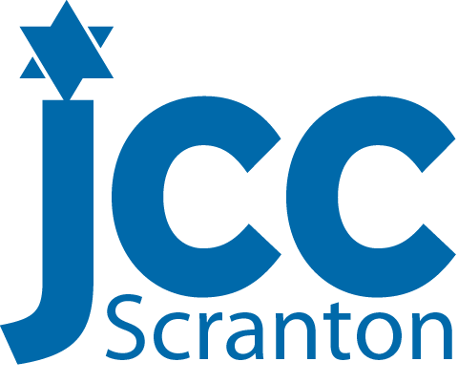

PHOTOGRAPHY RELEASE FORM
The Early Learning Center at the Scranton JCC is always trying to document all of the great activities and programming we do. These photographs highlight all the fun things your child does each day. We know that you enjoy seeing your child’s pictures, and getting a small glimpse at their day with us. We are requesting your permission to take pictures and videos of your child and acknowledge that the pictures and videos may be used in publicity materials, including our website. In addition, photographers from local newspapers and other media publications may occasionally come by the JCC to photograph our events and activities, which often include the Early Childhood Program.
Please sign below, in the appropriate spot, if you do or do not want your child photographed at our center.

I DO allow my child to be photographed at the Early Learning Center for media photos/and or publicity materials including Facebook.
Child’s Name: ________________________________ Class: ____________________
Parent/Guardian’s Signature:__________________________________Date:___________

I do NOT want to allow my child to be photographed for media photos and/or publicity materials, including Facebook.
Child’s Name: ____________________________________Class:________________
Parent/Guardian’s Signature: __________________________________Date:________

